Name _________________________________________ Date ________________________
Lab: Glaciers and Climate Change Period _______________________

Glaciers and Climate Change
Part 1:
Photos of glaciers past and present have been provided to each group. Match the past photo of a named glacier to a present photo from the same location, and then fill in the chart with your observations. Your observations may include things that have changed and things that have stayed the same. You must have at least 2 observations for each glacier.

Name of Glacier | # of Years Difference | Observations (What is the same? What is different?)
Muir Glacier (1941)
Carroll Glacier
Holgate Glacier
McCarty Glacier
Muir Glacier (1899)
Toboggan Glacier
Muir Glacier (1976)
Penderson Glacier

Part 2:
Use the graphs to answer the questions concerning impacts of global warming and sea ice loss.

Graph 1: Carbon Dioxide and Temperature
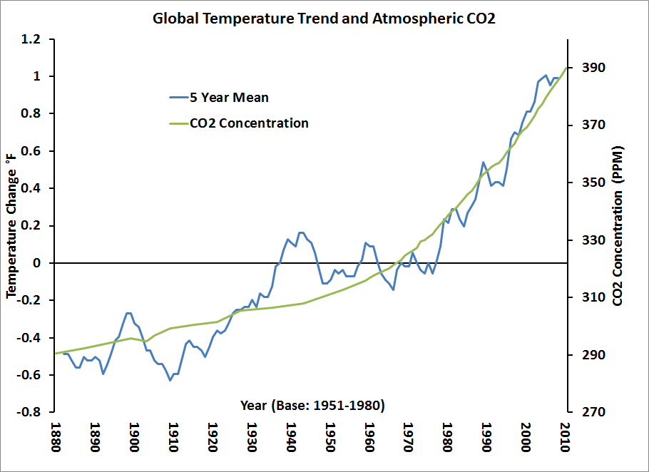

- What trend do you see in the carbon dioxide concentration as time goes on? ________________________________________________________________________

- What is considered to be the biggest cause of the carbon dioxide trends shown? ________________________________________________________________________

- Name 2 ways humans can contribute, even in small ways, to a reduction in carbon dioxide concentration on a global scale. ________________________________________________________________________________________________________________________________________________________________________________________________________________________

Graph 2:Carbon Dioxide Concentration
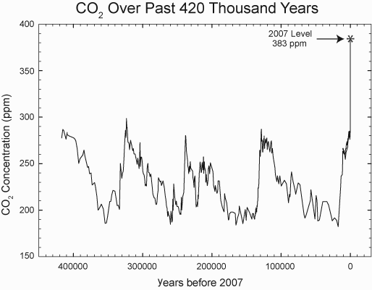

- What do you notice about the trend in carbon dioxide concentration over the past 420 thousand years? Are there any patterns? _______________________________________
________________________________________________________________________________________________________________________________________________

- Why are people so concerned about this trend in RECENT years? Look at the graph and see if anything stands out. __________________________________________________
_______________________________________________________________________

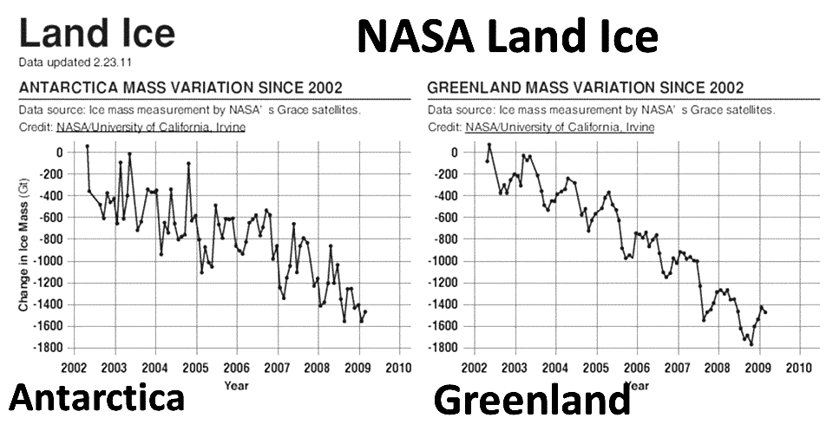
Graph 3: Ice Masses

1. How has the ice mass been changing within the last decade? __________________________________________________________________________

2. Compare the change in ice mass from the Northern Hemisphere (Greenland) to the Southern Hemisphere (Antarctica). __________________________________________________________________________
Graph 4: Sea Level
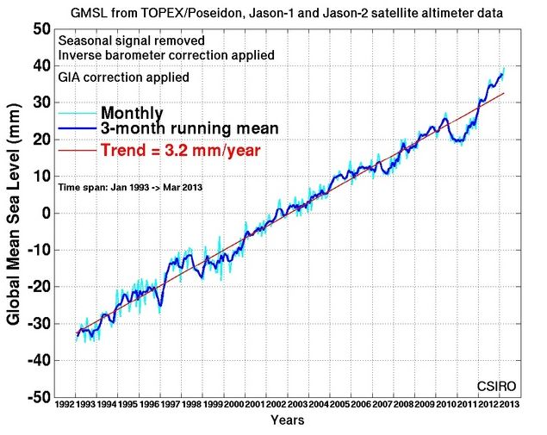

1. What trend do you see in sea level based on the graph? ______________________________________________________________________

2. What are some negative impacts of sea level rise that you can think of? List at least 2.
____________________________________________________________________________________________________________________________________________________

Map of Sea Level Rise Extent
*with blue pencil, color the map between the CURRENT U.S. continental edge and the PREDICTED extent of sea level rise if all of the ice were to melt.


